Model Development Phase Template

Date | July 2024
Team ID | 740053
Project Title | Estimating the Stock keeping units using Machine Learning
Maximum Marks | 10 Marks

Initial Model Training Code, Model Validation and Evaluation Report
The initial model training code will be showcased in the future through a screenshot. The model validation and evaluation report will include a summary and training and validation performance metrics for multiple models, presented through respective screenshots.

Initial Model Training Code (5 marks):
Paste the screenshot of the model training code

Model Validation and Evaluation Report (5 marks):
Model | Summary | Training and Validation Performance Metrics
Model 1 | Linear regression model typically include mean square error,R2 score to evaluate its predictive performance and generalization capability. | 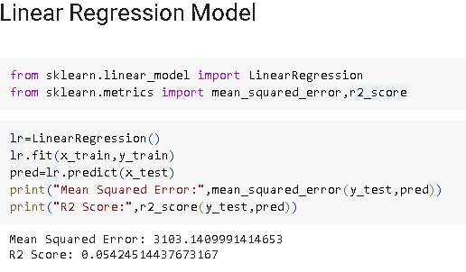
Model 2 | Random forest regression model often encompass mean square error, recall, R2 score to measure its prediction quality and robustness. | 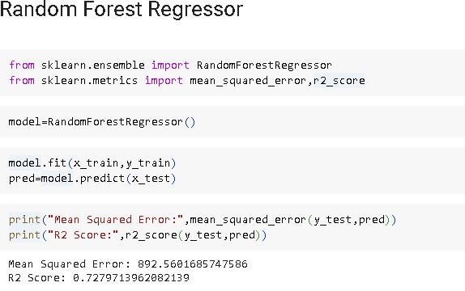
Model 3 | Decision tree regression model commonly include accuracy, precision, recall, R2 score which help assess the model's prediction accuracy and generalizability. | 